Teaching the Passion Narrative

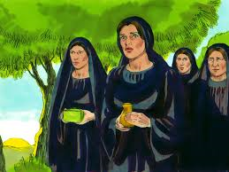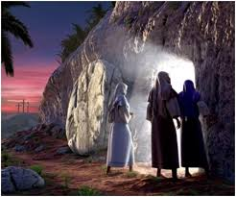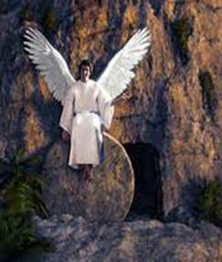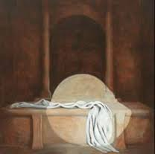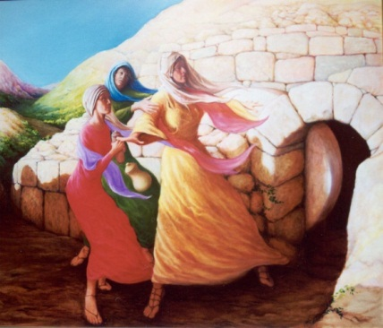

Prep Focus: Teaching Prep students about the resurrection of Jesus - Mark’s Gospel (Religion Curriculum - Scared Texts STNT2 and Beliefs BETR2)

WORLD OF THE TEXT: Mark 16:1-8 New Revised Standard Version Catholic Edition (NRSVCE)

The Resurrection of Jesus
16 When the Sabbath was over, Mary Magdalene, and Mary the mother of James, and Salome bought spices, so that they might go and anoint him. ² And very early on the first day of the week, when the sun had risen, they went to the tomb. ³ They had been saying to one another, “Who will roll away the stone for us from the entrance to the tomb?” ⁴ When they looked up, they saw that the stone, which was very large, had already been rolled back. ⁵ As they entered the tomb, they saw a young man, dressed in a white robe, sitting on the right side; and they were alarmed. ⁶ But he said to them, “Do not be alarmed; you are looking for Jesus of Nazareth, who was crucified. He has been raised; he is not here. Look, there is the place they laid him. ⁷ But go, tell his disciples and Peter that he is going ahead of you to Galilee; there you will see him, just as he told you.” ⁸ So they went out and fled from the tomb, for terror and amazement had seized them; and they said nothing to anyone, for they were afraid.
A study of the text itself – what happens in this story? Who is in the story? Where does the story take place? When does the story take place? Why might the author have written this story – what did the author want people in his community to understand about Jesus? Complete any activities that you could complete with a good literature book, that immerse students in the actual story itself. The aim is to do this well enough so that students can retell the story themselves using Biblical ‘puppet’ characters.
- Introduce students to the Passion Narratives from Palm Sunday through to the Resurrection – Explicit teaching of the Resurrection according the Gospel of Mark.
- Role play using costumes
- Easter story cube using homemade figures
- Word and picture wall to share feelings and thoughts about the events
- Easter Calendar with pavlova eggs
- Retell using the Easter garden
- Big books about Easter
- Sequencing pictures of the resurrection
- Create an exploding cross - The students paint a shoe box brown and illustrate a part of the Easter story of their own choice on paper and this is pasted inside the shoe box. Then attach all of the boxes together to make a class 3D cross.

WORLD BEHIND THE TEXT:
Go through the text and find all the words, concepts, places, people that won’t make any sense to prep children today – but they would have probably made perfect sense if students had lived in the time when the text was written. This process identifies what needs to be taught for ‘The World Behind the Text’.
Some ideas:
- Jewish Sabbath
– Goes back to the story of Creation in Genesis 1 – Six days of creation and Shabbat
– Jewish word for Sabbath day of rest which is Friday sunset to Saturday sunset.
- The Christian tradition - day of rest is Sunday.

- Mary Magdalene, Mary mother of James, and Salome are followers of Jesus and are in other stories of Jesus. The women were early followers of Jesus. It is an unusual story because the women are the main focus in the story. In the world of the time women held a lower place than men, for example they were not allowed to be witnesses in legal actions.

- Anointing with spices – how Jewish people prepared for burial.

- Tomb – The burial place of wealthier Jewish people was often in a stone tomb in a garden.

Resources:
- Use images from Nazareth Village and Free Bible Images(http://www.freebibleimages.org/)

- Use DVD’s – Son of God (BBC- ABC Shop); Daily Life in the time of Jesus - (www.biblelandshop.net) – Chapter 15 – Shabbat; Chapter 34- Resurrection.

WORLD IN FRONT OF THE TEXT:

What questions can we ask of the text to make it meaningful for us today? What relevance does an ancient text have for us today?
- What do you think people could learn about Jesus from this story today? What might the author have wanted people to understand about Jesus?
- Sometimes it is really hard to be a good follower of Jesus and live the way that Jesus would want us to live. Even the disciples struggled to do this sometimes. But this story tells us that when life seems too tough, Jesus is still waiting to help us, and even though Jesus is not with us anymore as a real live person walking around, his spirit can help us. We can’t see Jesus anymore, but we know the presence of Jesus is still with us in a different way. Every time believers celebrate Mass, the people gathered believe that Jesus’ spirit is there with them, helping them to be all that God wants them to be. Believers can still talk with Jesus today, in their hearts, through prayer.
- This story about Jesus is a special story to help people understand that when someone dies, their body dies, but their spirit (the part inside that no one can see – the love that a person has inside) cannot die. That means we can’t see Jesus as a person anymore, but we can still feel his love, deep inside us and around us.
- The resurrection story is a story of amazing hope. When things look too hard, too tough and too difficult God’s love can still break through and help us. The resurrection story tells believers that death is not the end, but the start of a new life with God. Easter is about celebrating new life.
Learning Experiences:
- Class discussion and role play: how Jesus can help us today.
- Continue with exploding cross – When the students return after Easter, have the 3D cross covered in green vines, white butterflies, white flowers etc. to show new life and the resurrection of Jesus.
- Relate the Easter gardens to new life with changing the colour of the ribbon from purple to white and move the stone and add a butterfly. (Display on Prayer table)
- Relate to the Hungry Caterpillar story by Eric Carle and participate in various activities to retell the story.

